RI Foreign Minister Meets Norwegian Foreign Minister and ASEAN Secretary General, Discuss Myanmar and Energy Transition

Jakarta, 14 July 2023. Minister of Foreign Affairs Retno Marsudi held a trilateral meeting with the Minister of Foreign Affairs of Norway and the Secretary-General of ASEAN, on the sidelines of the ASEAN Ministerial Meeting/Post Ministerial Conferences (AMM/PMC), Friday (14/7) in Jakarta. The meeting mainly discussed economic cooperation, energy transition, Myanmar's humanitarian aid issues and advancing the agenda related to Women, Peace and Security (WPS).

In her opening remarks, Minister of Foreign Affairs Retno Marsudi encouraged the strengthening of economic relations between ASEAN and Norway. For eight years, the ASEAN-Norway Sectoral Dialogue has generated significant cooperation in the areas of human rights, energy, and climate change. Trade relations between the two sides have also tripled through ASEAN-EFTA.

"We look forward to strengthening economic relations, including through the conclusion of the ASEAN–EFTA Joint Declaration on Cooperation," Retno said.

Furthermore, Foreign Minister Retno conveyed two priority issues to enhance the ASEAN - Norway partnership. First, maintaining Indo-Pacific peace and stability. Retno reiterated the importance of collaboration in the region. ASEAN will continue to strive to build an inclusive regional architecture. In this regard, Retno invited Norway to support the ASEAN Outlook on the Indo-Pacific and amplify ASEAN's spirit of dialogue and collaboration to the European region and the world.

Second, accelerating ASEAN's energy transition. Foreign Minister Retno emphasised that the energy and climate change sectors remain the flagship of ASEAN – Norway cooperation. Last year, ASEAN - Norway agreed to strengthen cooperation by disbursing funds of approximately USD 2.5 million for the next 4 years.

"Amidst the current challenging global situation that is full of rivalries, ASEAN needs support from all its partners, including Norway, to manifest its vision as an Epicentrum of Growth," Retno said.

During the meeting, Retno also invited Norway to support the implementation of the Five Point Consensus (5PC), especially in terms of providing humanitarian assistance. Furthermore, Retno conveyed the progress of providing humanitarian assistance that has been carried out to Myanmar through the AHA Centre.

In addition, the meeting also discussed the advancement of the Women, Peace, and Security (WPS) agenda. Retno urged Norway to support the implementation of the ASEAN Regional Plan of Action on Women, Peace and Security.

The Norwegian Foreign Minister expressed her appreciation for Indonesia's chairmanship of ASEAN. She also affirmed Norway's support for ASEAN's centrality in maintaining Indo-Pacific stability. Furthermore, Norway welcomed cooperation with ASEAN in the field of security and strengthening the Women, Peace, and Security (WPS) initiative.

***

For further information, please contact the following:

Director for Information and Media of the Ministry of Foreign Affairs - Hartyo Harkomoyo (+62811831899)

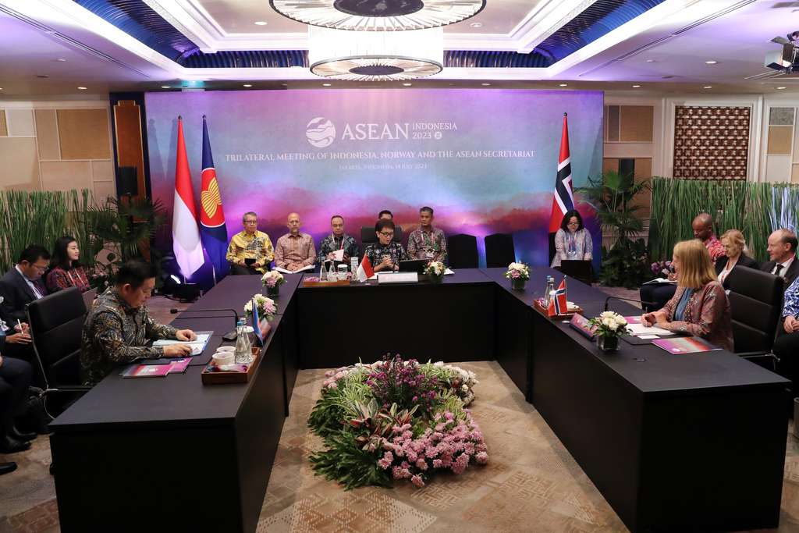

Minister of Foreign Affairs Retno Marsudi held a trilateral meeting with the Minister of Foreign Affairs of Norway and the Secretary-General of ASEAN, on the sidelines of the ASEAN Ministerial Meeting/Post Ministerial Conferences (AMM/PMC) in Jakarta (14/7) (Photo: Ministry of Foreign Affairs of Indonesia.

